**Agency, structure, discourse and entrepreneurship:**

**Understanding the transition of former auto regions**

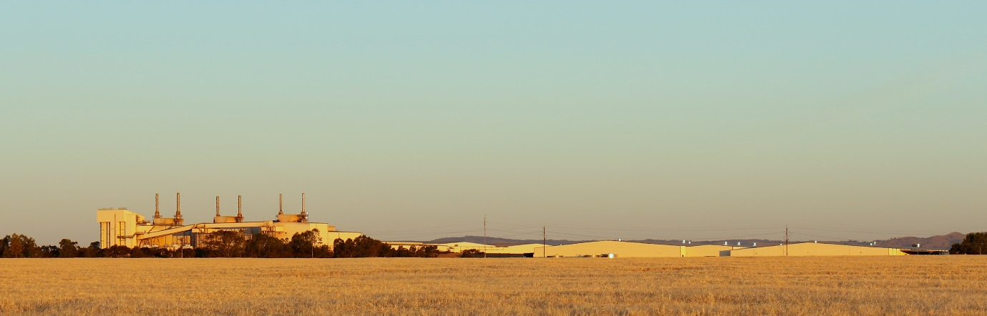

Andrew Beer

University of South Australia Business School

Paper presented to the School of Management

The University of Bath

11 November 2019



**Agency, structure, discourse and entrepreneurship:   
Understanding the transition of former auto regions**

**Andrew Beer**

This presentation sets out to better understand how regions that have experienced a major economic shock can establish a new economic future. It examines the recent writings of Grillitsch et al (2019) to better understand the drivers of agency, focussing in particular on the capacity of entrepreneurs to drive innovation leading to growth; the role of institutions as critical actors in change processes, and the part played by place leaders. This perspective is considered alongside the work of Moulaert et al (2016) and the emphasis they have placed on the role of discourse. These ideas are then applied to the examination of the community impacts of the closure of Australia’s automotive sector. [1]

**Regional economic change: A personal perspective**

In many respects, this paper and this presentation represents a personal journey for me in terms of my own research career and the ways in which I understand regional processes. For me this journey started in early 2004 when Mitsubishi Motors Australia Ltd (MMAL) announced its plans to close its plant at Lonsdale, South Australia. This plant, which had been built in the 1960s in a new, modernist industrial precinct, was located south of the city of Adelaide in a rapidly growing set of suburbs. The plant produced engine blocks and front-end assemblies that were then transported a few kilometres down the hill to the MMAL assembly plant at Tonsley Park. Flinders University, where I worked at that time, was in the same suburb. That wide ranging study – it covered health, labour markets, community impacts and housing – led me to consider both the nature of government interventions during large scale plant closures, and the ways in which regions create a new future for themselves at a time of economic shock. That latter topic was very much in accord with previous work I had undertaken with my collaborators on the nature of economic development agencies in Australia and other nations (Beer, Haughton and Maude 2003).

For me, the MMAL study raised an important challenge because it was via this work that I met Prof David Bailey and the team he was leading that examined the impacts of the MG Rover car closure in Birmingham. Being intimately involved with the MMAL study and in correspondence on the MG Rover research I became aware of an enormous disparity: of the MMAL workers, only one third found full time employment after being retrenched, one third exited the labour force and one third were essentially under-employed. By contrast Bailey et al reported 80% of displaced workers were in full time work one year post closure, an outcome that was attributed to the actions of the West Midland RDA and its philosophy of ‘hoping for the best while planning for the worst’. Clearly, the West Midlands had performed a trick that Southern Adelaide and the wider South Australian economy had missed.

Later I undertook other work for the Australian Government that examined the distribution and impact of structural adjustment packages (Beer 2015) and discovered (with some assistance)[2] that that over the period 2000 to 2012 the Australian Government announced more than $88bn in structural adjustment packages. However, many of those programs have low to very low rates of take up, and there was an interesting trend for many regions – and some regionally-focussed industries – to be repeat consumers of industry or regional assistance[3]. Not all was as it seemed, and perhaps it had been naïve of me to expect that such structural adjustment programs would have any impact in reshaping the economic trajectory of regions[4]. But it did raise an important question, ‘Why are some regions able to move with apparent ease from one economic structure to the next, while others do not?’ For me, this discussion then began to focus on questions of regional leadership and questions around the agency of individuals, groups and institutions, leading to a number of papers on that topic. My most recent published contribution in this area (Beer et al 2019) used the hypothetical closure of a large-scale manufacturing plant as the vignette through which cross national comparisons could be drawn.

In mid-2018 a group of us were fortunate to receive a large grant from the Australian Research Council (ARC) to examine the closure of the Australian car industry (Beer 2018) and its impact on workers and their communities (Beer, Weller et al 2019; but see also fwfc.com.au). Australia is not alone in witnessing the decline of automobile production and the closure of plants, but it is distinctive in the absolute closure of its industry. This sea-change in Australia’s economic landscape raises many questions of policy and theory and our work includes four distinct streams of work:

1. A longitudinal analysis of outcomes for workers, with five waves of interviews undertaken with a commencing population of approximately 1,000 respondents;
2. The conduct of longitudinal Discrete Choice Experiments (DCEs) with persons drawn from that sample, to better understand how workers navigate the labour market in the 21st Century;
3. Qualitative interviews with specified groups – women, persons from Culturally and Linguistically Diverse backgrounds (CALD) etc;
4. The examination of leadership at the regional level and an examination of community impacts.

This paper focusses on the fourth theme, which Markku Sotarauta and I lead. During his visit in June 2019 we began to consider the conceptual framework within which leadership was enacted, and potentially, new regional pathways forged. Importantly, the early indications are that regions affected by the closure of the car industry have not suffered the poor labour market outcomes and depressed local economies evident when MMAL closed. Indeed some of these regions appear to boast vibrant economies just two years post closure. So is the difference the new approach applied in the affected regions this time around – larger, longer term assistance and a slow-speed process of closure, and if so, what does it tell us about the nature of regional growth and path-changing processes?

**A conceptual framework**

Recently, Grillitsch, Rekers and Sotarauta (forthcoming) set down their thinking on path-changing and path-shaping amongst regional economies, with their conceptualisation having emerged from a large-scale, long-term research program called ReGrow undertaken in Scandinavia. This work will be published as a chapter in the *Handbook on City and Regional Leadership* entitled *‘Trinity of Change: Connecting Agency and Structure in Studies of Regional Development’*. Some aspects of this program of work have been discussed in other articles and in aggregate the work of Grillitsch, Sotarauta and colleagues represents a bold attempt to better understand agency and why some regions grow and reshape their economic trajectory, while others do not. It is important to consider this framework in some depth if we are to apply it empirically to the understanding of regions generally and the interpretation of events in former auto-producing regions specifically.

Grillitsch and Sotarauta (2019 p 2) begin their analysis with reference to Rodrigeuz-Pose (2013) and the observation that ‘some regions grow significantly more than could be expected, given their preconditions, while the opposite is true for other regions’. They reflected on the two theoretical traditions within economic geography that have ‘tackled’ the question of path development: evolutionary theory and institutional theory. Where evolutionary theories of path development ‘must be *dynamical*, must deal with *irreversible* processes and; and they must cover the generation and impact of *novelty* as the ultimate source of self-transformation (Boschma and Martin 2007 original emphasis). Essentially theories based on evolutionary economic geography rely upon path dependent processes where previous events shape the probable future outcomes. As Grillitsch and Sotarauta (2019) note, this makes for a relatively rigid and fixed set of pathways that take considerable time and effort to change. Importantly from the point of view of this paper, evolutionary perspectives say very little about micro-level processes, the minutiae of how and where decisions were taken or events unfolded to shape a new future. Grillitsch and Sotarauta (2019) have argued that institutional perspectives on regional pathways have suffered from a similar myopia with respect to micro-level processes. Institutional approaches seek to understand the role of relatively static institutions have played in shaping economic pathways such that there is

…a dearth of knowledge about what actors do to create and exploit opportunities in given contexts, why they do so in some places and not in others, and why the effects of such efforts differ between apparently similar places…. and that the blind spot is the role of agency and its relationship to structure (Grillitsch and Sotarauta 2019 p 2).

Grillitsch et al (forthcoming) argued that if we are to understand how regions reshape their trajectory we need to foreground two ideas:

* Agency – the actions people as individuals, or collectives take, or decisions they decide upon, to bring about change. These decisions and actions stem from conscious intent and for (Grillitsch and Sotarauta 2019 p 4) ‘a regional growth path can hence be seen as the nexus of intentional, purposive and meaningful actions of many actors, and the intended and unintended consequences of these actions’; and,
* Opportunity space – what is possible with respect to the global stock of knowledge, prior regional preconditions and the capability of the actors in place[5]. This concept provides a link to social and economic structure and forces us to consider the realm of possibilities confronting a region and how that is shaped by history, infrastructure, natural assets, national and global economic conditions etc. Grillitsch and Sotarauta (2019) argued that ‘actors are embedded in an opportunity space that is specific to a region, industry and time in question … the concept of opportunity space captures agents’ deliberations about the future. Agents reflect in a strategic manner considering how their actions might affect this evolution’ p 10).

Recent work by Eversole and Walo (2019) has provided a powerful example of the important distinction between agency and opportunity space: their analysis of submissions to an Australian Government Senate Committee noted that while regional organisations highlighted their capacity to provide leadership at the local level

Regional organisations gave few examples of how they were mobilising their knowledge to lead change. Nearly all these examples focussed on successfully securing external funding (p 14).

In this instance Australian regional development agencies believed they had the capacity to shape change, but were limited by governance and funding arrangements to simply securing grants for central-government endorsed projects. In a similar vein, Cleve et al (2019) noted that cities in Ontario developed plans to deal with the challenges of de-industrialisation, but commonly reported they lacked the resources needed to deal with these issues, and were unable to secure financial support from central governments to bring to life the plans they developed.

In focussing on opportunity space and agency, Grillitsch and Sotarauta (2019) sought to differentiate their analytical framework from those of others – eg, Giddens and his writings on structuration theory – by focussing on concrete processes shaping regional outcomes. A key part of their argument was the proposition that too much conceptualisation around this set of issues has taken place at a very abstract level, which has made the translation from theory to practice difficult.

The authors identified three types of change agency:

* Innovative entrepreneurship which serves as the path-breaking trigger for innovations that generate new economic opportunities;
* Institutional entrepreneurship: where key actors seek to change institutions and thus challenge the status quo;
* Place-based leadership where groups work together to combine competencies and resources.

This categorisation is more fine-grained than other typologies, such as Hassink et al’s (2019) suggestion that agency has two dimensions – firm agency and system agency. This potentially reflects a focus on the motivations underpinning actions: Firms, institutions and communities have very different reasons for taking action, with each potentially producing different outcomes while complementing – or being in conflict – with the others.

Similarly, Grillitsch and Sotarauta identified three types of opportunity space:

* Time specific – what is possible given the current stock of global knowledge, institutions and resources;
* Region specific – reflecting regional preconditions; and,
* Agent specific – captured perceived opportunities and capacities of individual agents to make a change.

At its core, the ReGrow project has conceptualised an analytical framework that is focussed on understanding action at a variety of spatial and temporal scales (Figure 1). It is an approach that accepts the impact and importance of multi scalar processes, and the capacity of challenges and initiatives to both span boundaries and ‘jump’ scales.

**Figure 1. The ReGrow Model: Agency and opportunity spaces**

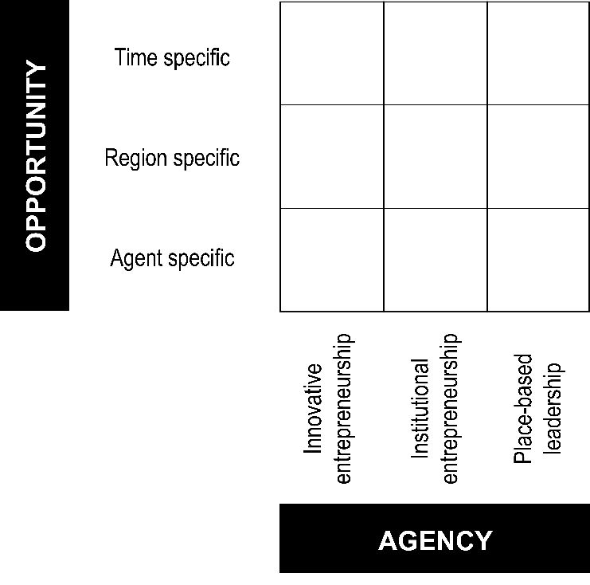

With the three forms of agency/action forming a ‘trinity’ of change potential that work in combination at a micro-level to reshape development pathways and this insight shares much in common with Hassink et al’s (2019) observation that new industrial pathways emerge from multiple actors. Importantly, Grillisch et al (2019) did not see entrepreneurship and the dynamism of agency as limited to one type of actor, they did not presuppose that the capacity to reconfigure local economic conditions necessarily resides with the private sector, institutions and government agencies, or communities. Instead they acknowledge the fluid nature of power and influence and the potential for initiatives to arise from one of a number of quarters[6]. As Grillitsch and Sotarauta (2019) note

‘the trinity of change agency is a holistic conceptual framework that is derived by necessity … where one form of agency calls for or necessitates the other. Together they are the shapers of regional growth paths beyond the expected (p 15). ‘

Grillitsch, Sotarauta and colleagues have developed a distinctive, and potentially transformational, conceptual framework for understanding how regions change their economic trajectory and embark on a new development pathway. Other research has embarked on a comparable journey (Mouleart et al 2016) have described the outcomes of their work on the DEMOLOGOS project in which the researchers sought to survey economic development trajectories; evaluate their explanatory power; build a meta-theoretical framework for analysing development, establish methods capable of validating that framework; and, finally, undertake that validation. This task, of course, is much broader than the ambitions of the ReGrow project, spanning issues of society-wide culture; capital; regulation; and development history, as well as questions of agency, structure, institutions and discourse. It is this latter focus, which Moulert et al (2016) badge as ASID, that is of relevance here as they argue that

For an adequate account of socio-economic development processes one must refer to the *actions* that steer or influence development processes, the *structure*s that both constrain and enable action, the *institutio*ns that guide or hamper actions and mediate the relation between structures and action, and the *discourses* and discursive practices that are part of these agencies (p 168-169).

In many respects the work of the ReGrow project and the DEMOLOGOS initiative has converged in identifying a common set of dynamics or drivers, however, the latter has singled out discourse as a key variable while the former did not. Critically, Moulert et al (2016 p 169) argue

Discourse is the production of intersubjective sense or meaning-making. It is an essential moment of action (as meaningful behaviour).

This definition, of course, resonates with the essence of the (now) very substantial body of work on transformational place leadership, and the role of place leaders in both developing a common understanding and sharing that vision more broadly. It also links with work that has emphasised ‘joint expectations’ and ‘conventions’ amongst private firms and public institutions as a basis for shared action (Hassink et al 2019). Overall we can conclude that the ReGrow model can be expanded to incorporate discourse as a key determinant of regional trajectories and as a focus for action-oriented research (Figure 2).

**Figure 2. Discourse, agency and opportunity spaces: a framework for action and analysis**

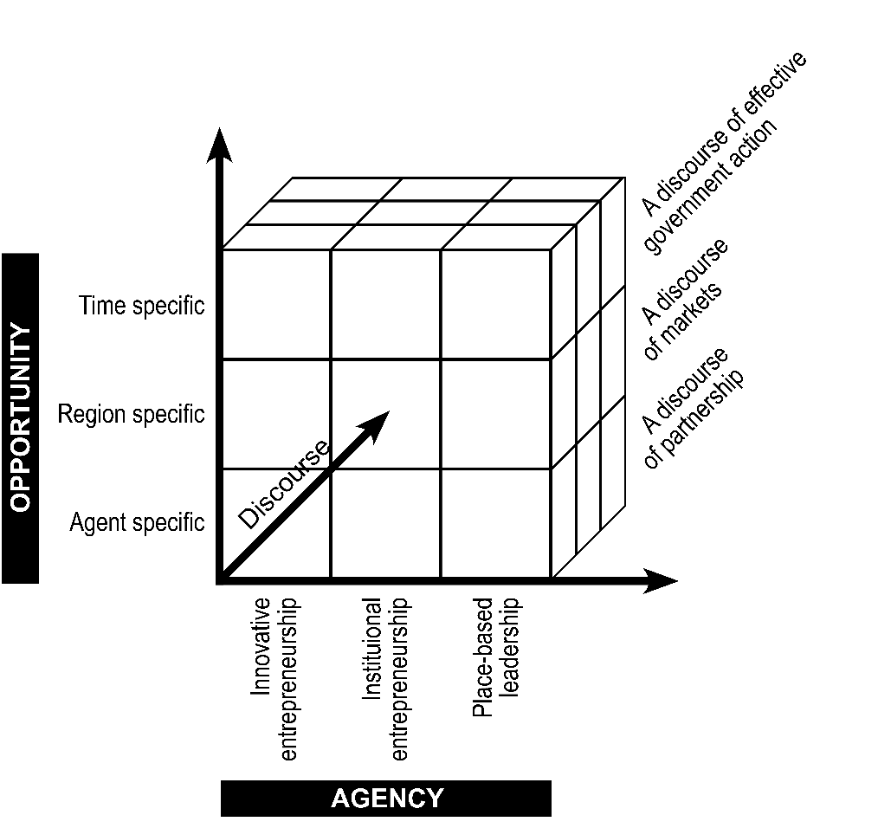

The important distinction between the work of the ReGrow researchers and the DEMOLOGOS group is that while the former is grounded in seeking an answer to a concrete empirical question – why do some regions grow better than expected – the latter is a decidedly meta-theoretical project that seeks to provide a near-universal conceptual framework for the interpretation of society and the economy. From the perspective of this paper and my starting question – ‘Why are some regions able to move with apparent ease from one economic structure to the next, while others do not?’ – the scholarship of the DEMOLOGOS team appears unfocussed, concentrating on creating a typology of research approaches rather than posing – and answering – specific research questions. However, in the context of this paper, the work of Moulaert et al (2016) is important in directing us to more closely examine the development and impact of discourse, in and of itself, not just as a dimension of place leadership[7].

**Operationalising this paradigm**

The ReGrow research program used the following suite of methods to distinguish the effects of general structural conditions from the actions of stakeholders:

* Step 1. Identified **extreme cases,** which were regions that had growth trajectories that departed substantially from the expected. They did so by using quantitative analysis over a 25 year time frame. This analysis provided the justification for the regions they selected for in-depth investigation;
* Step 2. The research selected particular examples or exemplars for further investigation from amongst the extreme cases. They looked to maximise the level of variability with respect to outcomes and trajectories while allowing for cross-case comparisons. They selected each of these exemplars on the basis of **regional profiles** prepared for the purpose;
* Step 3. They developed common **regional stories** through their comparative analysis, and these common stories led to the identification of regions operating under similar constraints. They then selected exemplars that allowed for **comparisons** across at least two common stories (X and Y faced similar conditions, how did both fare?) and **variation**: cases representing different conditions across common stories (A and B represented different economies, with both experiencing a transition).
* Step 4. Was comprised of theoretically informed case study selection.
* Step 5. Once the case studies were selected, the researchers used retrospective interview data and archival analysis to understand agency (what people did, why, how they came to do that, and to what effect).

They undertook this analysis with a focus on:

1. Identification of critical junctures and the types of junctures they experienced;
2. Characterisation of sequences of events and their properties;
3. Dependencies from one event to the next;
4. Evaluating theory-derived assumptions of agency and causality to identify generative mechanisms and/or a plotline; and,
5. Identification of coherent patterns that represent a clear narrative and an explanation.

Importantly, they argued that through this process it is possible to identify a **critical juncture[8]**, which is a set of conditions and opportunities because it has the potential to give rise to a new path dependent process (and set of outcomes) and economic trajectory. They argued that these junctures can be recognised because:

* A range of consequences is conceivable;
* Several such events are possible, but the outcomes of any and all of them cannot be predicted;
* The timing and sequencing of these events is important[9]; and,
* The critical juncture creates a new path that is resistant to change.

**Discussion and conclusion**

This paper is a preliminary attempt to grapple with the question ‘Why are some regions able to move with apparent ease from one economic structure to the next, while others do not?’ It has reviewed recent writing related to this topic, and in particular it has paid attention to the work of the researchers engaged on the ReGrow project. It has attempted to better understand their theoretical framework for both conceptualising the determinants of regional growth or decline, and the most appropriate methods of empirical analysis. This body of work has been considered alongside the ASID meta theoretical approach, with particular attention afforded to the potential capacity of discourse to shape regional outcomes.

What then can we conclude from this review? What are the key lessons, and what guidance can this examination of material offer for our developing research into the impacts of the closure of the Australian automobile industry on affected regions? Firstly, the ReGrow approach, in common with Mouleart et al’s (2016) ASID framework, is most appropriately considered a critical realist epistemology, but it is a ‘meso level theory’ rather than the meta theoretical approach we see with ASID (Kemeny 2013). It is an approach that makes use of both quantitative and qualitative methods but, as with most critical realism, the qualitative evidence is essential to the construction of causality. Secondly, we can consider the ReGrow approach to be a meso level theory in the sense that it draws attention to the need to address all aspects of the three by three framework of agency and opportunity space. It does not suggest which part of that matrix is likely to determinant of outcomes, instead leaving open the possibility that any or all factors can exert a critical influence under appropriate conditions.

Third, I would argue that the foregrounding of the concept of a ‘critical juncture’ is an important contribution to regional research broadly, and the understanding of pathbreaking and path branching at the urban or regional scale especially. The work of Grillitsch, Sotarauta and their colleagues suggests that many events have the potential to emerge as critical junctures, but do not eventuate as such as path-changing opportunities were not present and/or critical interventions were not enacted by any of the three forms of agency in the region. It may be that potential critical junctures are recognised at the time, but these opportunities to transform are left unfulfilled. This may be because unproductive options are taken up as established, vested interests, seek to preserve their privileged position or decision makers with an inadequate stock of knowledge around the potential likelihood of success attached to alternative development strategies choose less productive paths. It may also be the consequence of the absence of human capital, limited financial capital or other resource constraints.

Fourth, Grillitsch, Sotarauta et al have made a convincing case around the capacity of their approach to compare regions, but it is less clear that this method is equally valuable in undertaking a longitudinal analysis. More specifically, the reliance on in-depth interviews and other qualitative techniques may limit the capacity to understand how a region entered a critical juncture in one period, but took a completely different course of action (with consequently different outcomes) at another time period. To use the example of automobile plant closures in Australia, it may be impossible to fully understand the decisions taken when MMAL closed its Tonsley Park plant in 2008 in order to compare them with the processes in effect when General Motors Holden shut down in 2017 as key informants are no longer available.

Fifth, the ReGrow framework leaves open the question of spatial scale. While, to a European audience, the answer to this question may seem self-evident as there is a widely accepted categorisation and language around regions as a concept and an empirical category, in other nations it is a more complex, and contested, concept (see Eversole 2016). In the early 2000s responses to the MMAL closures were locally focussed and while there were positive dimensions to this micro-spatial scale (Beer and Thomas 2009), it limited the impact of actions intended to reshape the future of the region. Government programs were confined to subsidies for businesses, the establishment of (yet another) economic development agency, and the redevelopment of the MMAL sites – with one converted to a general-purpose industrial estate, and the second established as a university precinct, technology hub and residential development. Such developments have not had a measurable impact on regional economic performance (Beer 2015). By contrast, the closure of the car industry in its entirety of over the period 2014-17 was seen as a State-wide problem, and indeed a problem for all of south east Australia. The policy challenge then became one of national and state significance, and in analytical terms, questions of spatial scale then become questions of institutional arrangements.[10]

Sixth, the ReGrow framework significantly advances the literature on institutions as a force underpinning the growth and decile of regions. Importantly, it forces us to challenge the pronouncement by Rodriguesz-Pose (2013) that growth occurs not when regions have more or fewer institutions, but when the they have the ‘right mix’ of institutions (see also Safford 2004). While intuitively attractive, this perspective inevitably places regional institutions in a ‘black box’ with little prospect of shedding better light on their performance and outcomes. The ReGrow analytical approach posits an alternative viewpoint: that growth occurs when a region or city has the appropriate institutions for the existing or emergent opportunity space. This of course, begs the question of how such a match can evolve, but it does leave open researchable questions for policy and theory around how to bring such a marriage into effect. This in turn suggests any focus on place based or local leadership should zero in on how opportunities are understood and how local leaders incorporate and integrate that future-focussed perspective in their language and actions. If they are focussed on the past, leadership will not be transformational and the agency of positive change will not emerge.

Seventh, in the context of our ARC funded research, the work of Grillitsch, Sotarauta et al makes us appreciate the importance of the established economy and resource base in shaping regional outcomes. Put simply, the focus on opportunity spaces reminds us that places with stronger, wealthier economies that are richer in human capital and other resources have more options available to them as they go through an economic transition. To place that in context, there is anecdotal evidence that Victoria and its regions has experienced a better transition to a post-auto economy than South Australia – and this may be a consequence of a richer opportunity space rather than better leadership, though both are likely to have exerted some influence.

Finally, it is worth acknowledging that the challenge of understanding how regions change from one economic trajectory to another will continue to exercise the minds of regional researchers and other social scientists. The contribution made by scholars associated with the ReGrow project has been important, but we can look forward to further conceptual and empirical advances over the coming years.

**References**

Beer, A. 2015 Structural adjustment programmes and regional development in Australia, *Local Economy,* 30:1,pp 21-40.

Beer, A. Ayres, S. Clower, T. Faller, F. Sancino, A. and Sotarauta, M. 2019 Place leadership and regional economic development: a framework for cross regional analysis, *Regional Studies,* 53:2, pp 171-82.

Beer, A. Haughton, G. and Maude, A. 2003 *Developing Locally: International lessons in economic development*, Policy Press, Bristol.

Beer, A. Weller, S. Barnes, T. Onur, I. Ratcliffe, J. Bailey, D. and Sotarauta, M. 2019 The urban and regional impacts of plant closures: new methods and perspectives, *Regional Studies, Regional Science*, 6:1, 380-394, DOI: [10.1080/21681376.2019.1622440](https://doi.org/10.1080/21681376.2019.1622440)

Boschma, R. and Martin, R. 2007 Editorial: Constructing an evolutionary economic geography, *Journal of Economic Geography*, 7:5, pp 537-48.

Cleve, E. Vecchio, M. Spilsbury, D. and Arku, G. 2019 Manufacturing change and policy response in the contemporary economic landscape: How cities in Ontario, Canada understand and plan for manufacturing, *Regional Studies, Regional Science*, 6:1, pp 469-95.

Eversole, R. and Walo, M. 2019 Leading and following in Australian regional development: Why governance matters, *Regional Science, Policy and Practice,* <https://doi.org/10.1111/rsp3.12232>

Grillitsch, M. and Sotarauta, M. 2019 [Trinity of change agency, regional development paths and opportunity spaces](https://protect-au.mimecast.com/s/KOPvCE8w96t0KMmnsN0qaY?domain=journals.sagepub.com), *Progress in Human Geography*. DOI: 10.1177/0309132519853870.

Hassink, R. Isaksen, A and Trippl, M. 2019 Towards a comprehensive understanding of new regional industrial path development, *Regional Studies*, 53:11, pp. 1636-46.

Kemeny, J. 2013 *Housing and social theory,* Routledge, London.

Moulaert, F. Jessop, B. and Mehmood, A. 2016 Agency, Structure, Institutions and Discourse (ASID) in urban and regional development, *International Journal of Urban Sciences,* 20:2, pp 167-87.

Rodríguez-Pose, A. 2013 Do institutions matter for regional development? *Regional Studies,* 47:7, 1034-1047, DOI: [10.1080/00343404.2012.748978](https://doi.org/10.1080/00343404.2012.748978)

Safford, S. 2004 Why the Garden Club Couldn’t Save Youngstown, MIT Working Paper IPC-04-002, MIT.

**Appendix A Shortened List – Structural Adjustment Packages, Australian Government 2000-2012.**

Collaboration and Structural Reform Fund (CASR) 2005-2008 $36.3m  
Diversity and Structural Adjustment Fund 2008-2009 $50m for each

calendar year

Structural Adjustment Fund (SAF) 2009-ongoing $402m

Climate Change Adjustment Program (CCAP) ?-2012 $12.13m (for 2011-12)Clean Energy Future (CEF) Plan 2011-ongoing Up to $200mLatrobe Valley Industry and Infrastructure Fund (LVIIF) 2011-2013 $15mJobs and Competitiveness Program (JCP) 2012-ongoing $8.6b over the first 3 years  
Ipswich Regional Recycled Water and Economic Structural   
Adjustment Strategy (IRRWESAS) 2005-2020 Unknown  
Water Smart Australia (WSA) 2004-2011 $1.6b  
Water for the Future 2008-2018 $12.9b

* Murray Darling Basin Plan 2012-2024 $8b + $1.77b
* Restoring the Balance in the Murray-Darling Basin 2007-2017 $3.1b
* Strengthening Basin Communities Program 2009-ongoing $200m
* On-Farm Irrigation Efficiency Program (OFIEP) 2009-2012 $150m
* Strategic Sub-System Reconfiguration Program 2012-2016 $200m

FarmBis 1997-2009 (replaced by FarmReady) $172.7m  
Farm Help 2000-2008 $8.94m  
FarmReady 2009-2012 $34.4m  
Briquette Restructuring Package 2012-2014 $50m  
Green Building Fund 2008-closed $90m

Clean Energy Future $200m

* Clean Technology Investment Program 2012-ongoing $800m
* Clean Technology Food and Foundries Investment Program

2012-ongoing $200m

* Clean Technology Innovation Program 2012-ongoing $200m

Carbon Farming Initiative (CFI) $46m

* Carbon Farming Futures 2011-12 to 2017-18 $430m
* Indigenous Carbon Farming Fund 2012-13 to 2017-18 $22.3m

Biochar Capacity Building Program 2011-2014 $2m  
Achieving Sustainable Groundwater Entitlements (ASGE) 2006 $125m

Moreton Bay Marine Park Structural Adjustment Package   
(MBMP SAP) 2009-ongoing $15.1mSecuring Our Fishing Future Package (SFFP) 2005-Ongoing $220mGreat Barrier Reef Structural Adjustment Package 2004-ongoing $213.7mFisheries Adjustment Assistance Package (FAAP) 2012-ongoing $100m  
Victoria’s Marine National Parks and Sanctuaries   
Compensation Scheme 2003-2007 $4.33m  
Recreational Fishing Community Grants Program (RFCGP) 2005-2010 $15m

Queensland East Coast Commercial Net Fishing   
Reduction Scheme 2012-2013 $9m  
Commercial Fisheries Reform Package (NSW) 2012-2014 $16m  
Cod Grounds Commonwealth Marine Reserve Structural   
Adjustment Package 2007- $1.7m  
New South Wales Marine Parks Adjustments   
(Solitary Islands, Cape Byron, Port Stephens and Great Lakes,   
Jervis Bay, Batemans) 2002-2006 $32.8m  
Tasmanian Marine Parks Adjustment 2008 $50,000  
River Murray Fishery Licence Holders Restructure   
Adjustment Package 2005 Unknown  
Marine Scalefish Fishery buyback (SA) 2005 $12m  
Rock Lobster licence buyback (Vic) 2008-2009 $5m  
Tropical Rock Lobster fishery buyback (Torres Strait) 2011-2012 Unknown  
ECTF Structural Adjustment Scheme (East Coast Trawl Fishery) 2001 $20m  
Barramundi Licence Buybacks (NT) 2009-ongoing Unknown  
Victorian bay and inlet commercial fisheries – licence   
buybacks 2000 and 2005 Unknown  
NSW Oyster Industry Package 2004-2008 $3.1m

Tasmanian Forest Industry Development Program 2005-2006 $42m  
Tasmanian Country Sawmills Assistance Program 2005-2006 $4m  
Tasmanian Softwood Industry Development Program 2005-2006 $10m  
Tasmanian Forest Contractors Exit Assistance Program 2010-2011 $17m  
Tasmanian Forest Contractors Financial Support Program 2010-2011 $5.4m  
NSW River Red Gum Structural Adjustment Package   
(RRGSAP) 2010-ongoing $17m  
Forest Industry Structural Adjustment Package (FISAP) 1995-2006 $107m  
South-West Forests Structural Adjustment Package 2000-2001 $5m  
Tasmanian Innovation and Investment Fund (TIIF) 2011-closed $8m  
North West and Northern Tasmania Innovation and Investment   
Fund (NWNTIIF) 2009-? $20m  
North East Tasmania Innovation and Investment Fund (NETIIF) 2008-? $3.7m  
Eden Regional Adjustment Package (ERAP) $3.4m  
Our Forests, Our Future 2002-ongoing $80m  
North East Tasmania Micro Program (NETMicro) $600,000  
Tasmanian Forests Intergovernmental Agreement Contractors   
Voluntary Exit Grants Program (IGACEP) 2011-2012 Part of the TFIA  
Tasmanian Forests Intergovernmental Agreement 2011-ongoing $379m  
Forestry Industry in Tasmania Structural Adjustment   
Program 2011-2016 $14m

Dairy Structural Adjustment Program Scheme 2000   
(DSAP Scheme) 2000-2008 $1.63bSupplementary Dairy Assistance Program (SDA) 2001-2008 $120mSugar Industry Reform Package 2002-2003 $150mSugar Industry Reform Programme (SIRP 2004) 2004-2008 $444.4mTobacco Grower Adjustment Assistance Package (TGAAP) 2006-2007 $0.45m  
Premium Fresh Tasmania 2012-2013 $750,000  
Regional Food Producers Innovation and Productivity Program   
(RFPIPP) 2008-2012 $35m  
Wheat Export Technical Market Support Grants 2009-2011 $316,000  
Transitional Assistance Package (TAP) (grains) 2008- $9.37m  
Citrus Canker Assistance Package 2005-2007 $11.5m

Beaconsfield Community Fund 2006-closed $8.3mCoal Sector Jobs Package (CSJP) 2011-2012 $1.26b  
Point Henry Aluminium Smelter 2011-2014 $42m in 2011-12  
Coal Mining Abatement Technology Support Package   
(CMATSP) 2012-2017 $70m  
Hunter Advantage Fund (HAF) 1999-2011 $13mTextile Clothing the Footwear Structural Adjustment Package   
(TCF-SAP) 2005 to 2014-15 $35m  
TCF Strategic Investment Program (SIP) Scheme 2000-2005 Unknown  
TCF Post-2005 Strategic Investment Program Scheme 2005-2015   
(but replaced by the TCF Innovation Package in 2010) $575m  
Automotive Industry Structural Adjustment Program (AISAP) 2009-2012 $116.3mAutomotive Competitiveness and Investment Scheme (ACIS) 2001-2011 $7bStructural Adjustment Fund for South Australia   
(SAFSA) 2004-06 (Mitsubishi - Lonsdale) $55mSouth Australia Innovation and Investment Fund   
(SAIIF) 2008-10 (Mitsubishi – Tonsley) $30mSteel Transformation Plan (STP) 2012-2016 $300mBlueScope Steel Labour Adjustment Program 2011-2015 $9.9m

Illawarra Advantage Fund (ILAF) 1999-2011 $10mIllawarra Region Innovation and Investment Fund (IRIIF) 2011-2014 $30mPort Kembla Industry Facilitation Fund (PKIFF) 2006-closed $5m

Innovation and Investment Fund for South Australia   
(IIFSA) 2006-2010 (Electrolux) $30mGeelong Investment and Innovation Fund (GIIF) 2007-closed (Ford) $24mBridgestone 2010 $5.7mAutomotive Transformation Scheme (ATS) 2011-2020 $3.347b  
Australian Paper’s Maryvale Pulp and Paper Mill 2012-2015 $9.5m  
Clothing and Household Textile Building Innovation   
Capability Scheme (BIC) 2010-ongoing $112.5m  
Textile, Clothing and Footwear Strategic Capability Program   
(TCF SCP) to June 2015 $35m  
Textile, Clothing and Footwear Small Business Program   
(TCF SBP) 2005 to 2016 $2.5m

Wide Bay Burnett Structural Adjustment Package 2001-2002 $4mNewcastle Structural Adjustment Fund (NSAF) 1997-2000 $10mSouth East South Australia Innovation and Investment Fund   
(SESAIIF) 2011-2013 $24mScottsdale Industry and Community Development Fund (SICDF) 2007- $6mInsulation Workers Adjustment Package 2010-closed $41.2mInsulation Industry Assistance Package May 2010-July 2010 $15mQueensland Workers’ Assistance Package 2012-ongoing $850,000  
Regional Solutions Program (RSP) 2000-2003? $20.6m  
Sustainable Regions Program 2001- Unknown  
Regional Partnerships Program 2003- Over $400m  
Queensland Commercial Horse Small Business Emergency   
Assistance Scheme 2007-2008 Over $500,000  
Rural Resilience Package 2011-2012 $20m  
Commonwealth Flood Assistance Package for Central and   
Northern New South Wales and Southern Queensland 2000-2001 $151.7m  
Federal Flood Recovery Fund 2000-2001 $10m  
Federal Flood Mitigation Programme 2001-2005 $40m  
Approved Supply Chain Improvements Program 2011-2013 $5m  
Australian Government Disaster Recovery Payment (AGDRP)   
ongoing as needed Unknown  
Exceptional Circumstances Relief Payment (ECRP) ongoing as needed Unknown  
Exceptional Circumstances Exit Grant -2011 Unknown  
Exceptional Circumstances Advice and Retraining Grant -2011 Unknown  
Exceptional Circumstances Relocation Grant -2011 Unknown  
Murray-Darling Basin Small Block Irrigators Exit Grant 2008-2009 $57.1m  
Murray-Darling Basin Small Block Irrigators Advice and   
Retraining Grant 2008-2009 Part of the above funding  
Murray-Darling Basin Small Block Irrigators Removal Grant 2008-2009 Part of the above funding  
Live Animal Exports – Assistance to Individuals 2011-12 to 2014-15 $5.2m  
Live Animal Exports – Business Assistance 2011-12 to 2015-16 $30m  
Tourism Assistance Package (Queensland natural disasters) 2011 $12m  
Business Support Package (Victorian bushfires) 2009 $51m  
Tourism Industry Support Package (Victorian bushfires) 2009-2011 $10m  
Victorian Bushfire Business Investment Fund (VBBIF) 2010 $10m  
NBN Industry Assistance Package (Tasmania) 2012 $1m  
Tasmanian Health Assistance Package 2012-2016 $325m  
Heavy Vehicle Industry Assistance Package 2012 Unknown  
Fixing the Trains (RailCorp, NSW) 2012 Unknown  
Australian Interactive Games Fund 2012-2015 $20m

1. I met David through the Post Doctoral Researcher employed as part of the MMAL project, Dr Holly Thomas, who heard about the MG Rover collapse and travelled there to visit. Holly recounted that she almost froze to death in a snowstorm during that visit.
2. Thanks Sandy!
3. In a paper being developed by my colleague Assoc Prof Sally Weller from the University of South Australia Business School she argues that ‘political effects arise not from deindustrialisation, but from inadequate policy responses to localised crises….Australia’s timely crises interventions reassure voters they do ‘matter’.
4. Because I lack self-discipline I have included a shortened list of some of the packages in Appendix A.
5. This a very, very shorthand version.
6. This, of course, challenges neo liberal views that award primacy – and indeed sole authorship of economic futures – to the private sector and market processes.
7. I am struck by the fact that in 2004 and again in 2008 there was an assumption amongst Australian governments that the economic gap created by the MMAL plants would be filled by the growth of the mining industry, with workers made redundant from that sector easily moving to resource-based employment. By contrast in 2014 the successive announcements of the closure of Holden, Ford and Toyota plants in Australia were treated with all seriousness by government agencies and a much more comprehensive set of responses was enacted, possibly producing the apparently better than expected outcomes from the 2017 shutdown of the industry.
8. There is an interesting parallel with the critical incidents framework used in social policy analysis and life course research.
9. The work I did in 2012 on structural adjustment packages saw multiple individuals tell me that the timing of government responses was critical. In the Illawarra, the Bluescope closure saw Wollongong completely change its growth path.
10. Should we, perhaps, reverse the principle of subsidiarity and instead argue that issues are best dealt with by the most senior tier of government willing to pay attention?